WEEK 7
Date: |  | Day: MONDAY |  |  | Strand: All Around Us
 |  |  |  |  | SUB STRAND: CHANGING WEATHER CONDITIONS
Class: KG 1 |  |  | Class Size:
Content Standard:  K1.6.9.1 Demonstrate understanding of changing weather conditions and seasons. |  |  |  | Indicator:  K1.6.9.1.1 Sing and talk about the weather condition in Ghana.
Performance Indicator:  Sing and talk about the weather condition in Ghana. |  |  |  |  | Core Competencies:  Communication and collaboration (CC) Personal Development and Leadership (PL) Creativity and Innovation (CI) Critical Thinking and Problem Solving
Keywords: Plant, stem, root, leaves, fruits
Reference : KG Curriculum P.g. 76-79
Phase/Duration | Learners Activities |  |  |  |  | Resources
PHASE 1: STARTER 10 MINS  (Preparing the Brain for Learning) | Engage learners to sing songs and recite familiar rhymes  SIX LITTLE MICE  Six little mice sat down to spin,  Pussy cat passed and she peeped in.  What are you doing, my little men?  Weaving coats for gentlemen.  Shall I come in and cut off your threads?  No, no, pussy cat, you’d bite off our heads!  Oh, no, I’ll not, I’ll help you spin.  That may be so, but you don’t come in.
PHASE 2: MAIN 40MINS  (New Learning Including Assessment) | Have learners sing the “Rain rain go away song” and talk about the weather condition they sang about in the song. |  |  |  |  | Pictures and Charts, the big book, pencils and crayons
GROUP ACTIVITY 1  (OUTDOOR) | Go out of the classroom to observe the weather with learners.  Lead learners to recite a poem on the weather  e.g. Whether the weather” …  Using conversational poster on different weather conditions in Ghana, guide learners e.g. rainy, sunny, windy, cloudy, etc.  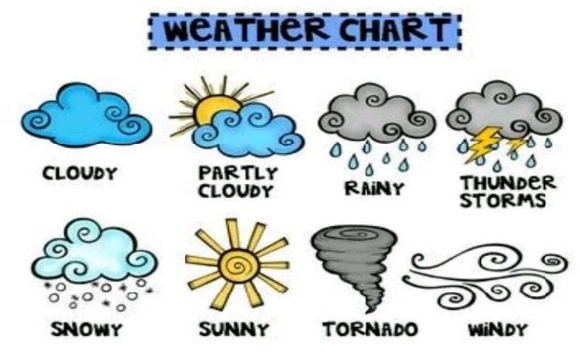  Have learners sound out the names of the weather condition and share personal experiences on weather conditions.  Engage Learners to use any of the play toys available.  Make a choice to use any of the learning centers created
PHONICS | Engage learners to sing songs and recite some familiar rhymes that relates to the target sound.  Guide learners to pronounce and write the target sound in the sand tray or exercise books.  Have learners say three or four words that contain the target sound.  Using flash cards, learners read words that contain the target sound.  1. What sound have we learnt today?  2. Which other letter sound do you know?  3. Mention any object in the classroom or home that begins with the target letter sound. |  |  |  |  | Word cards, letter cards.
GROUP ACTIVITY 2  (INDOOR) | Use leading question to introduce the sub-theme to learners.  Have learners sound out the names of the weather condition and share personal experiences on weather conditions.  Guide them to talk about the current weather condition. E.g. Sunny or cloudy weather.  Using a weather tally chart, guide learners to tally the weather for the week as a class project using different colors for different weather conditions.  Using a weather chart, discuss with learners how to cater for oneself during the different seasons.  Have learners be in pair and do charade depict what they do on different weather conditions. |  |  |  |  | Pictures and Charts, the big book, pencils and crayons
LEARNING CENTER | Engage learners to play freely at the learning centers.  Observe, join in and ask learners questions frequently to guide their play and to support their understanding in what they are learning. |  |  |  |  | Learning center
STORY SHARING | Tell learners a story.  Pause regularly and ask questions to make sure learners are following.  Engage learners to act parts of the story.  1. Was the story interesting?  2. What part of the story did you like?  3. what have you learnt from the story? |  |  |  |  | Word cards, letter cards.
PHASE 3: REFLECTION 10MINS  (Learner and Teacher) | Review lesson with Learners by singing songs in relation to it

Date: |  | Day: TUESDAY |  |  | Strand: All Around Us
 |  |  |  |  | SUB STRAND: CHANGING WEATHER CONDITIONS
Class: KG 1 |  |  | Class Size:
CONTENT STANDARD:  K1.6.9.1 Demonstrate understanding of changing weather conditions and seasons. |  |  |  | INDICATORS:  K1.6.9.1.2 Identify the cover page and illustrations and listen to and respond to a read aloud text on changes in the weather condition.
PERFORMANCE INDICATOR:  Identify the cover page and illustrations and listen to and respond to a read aloud text on changes in the weather condition. |  |  |  |  | Core Competencies:  Communication and collaboration, Critical thinking, Personal Development and Leadership
Keywords: Plants, medicine, shade
Reference : KG Curriculum P.g. 76-79
Phase/Duration | Learners Activities |  |  |  |  | Resources
PHASE 1: STARTER | Engage learners to sing songs and recite familiar rhymes  LITTLE TOMMY TITTLE MOUSE  Little tommy tittle mouse  Lived in a little house,  He caught fishes  In other men’s ditches.
PHASE 2: NEW LEARNING  CIRCLE TIME | In a community circle time, show the book and ask learners to identify the cover page, the writer/author and the illustrator.  Have learners use the cover page illustration and picture walk to predict the content.  Using Echo-reading, assist learners to read aloud the text. Ask questions during the reading to help you monitor their understanding. |  |  |  |  | Pictures and Charts, the big book, pencils and crayons
GROUP ACTIVITY 1  (OUTDOOR) | Use different questions (literal, leading, inference, critical) to guide learners respond to the text.  Have learners charade with selected sentences in the text e.g. It is raining so I am cold; it is sunny today; etc.  Have learners identify the weather conditions read about and tell the order in which they appeared.  E.g. rainy weather came 1st, sunny 2nd, windy 3rd, etc.  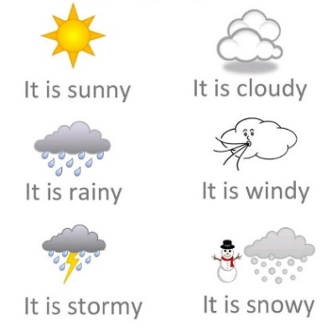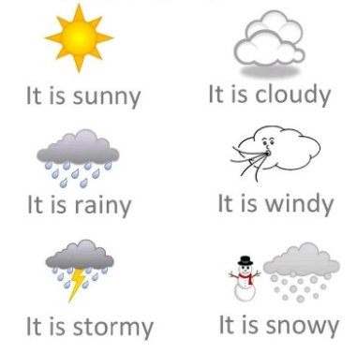 |  |  |  |  | Pictures and Charts, the big book, pencils and crayons
PHONICS | Engage learners to sing songs and recite some familiar rhymes that relates to the target sound.  Guide learners to pronounce and write the target sound in the sand tray or exercise books.  Have learners say three or four words that contain the target sound.  Using flash cards, learners read words that contain the target sound.  1. What sound have we learnt today?  2. Which other letter sound do you know?  3. Mention any object in the classroom or home that begins with the target letter sound. |  |  |  |  | Word cards, letter cards.
GROUP ACTIVITY 2  (INDOOR) | Have them tell the position of the following:  1 2 3 4 4 5 6 7 table chair duster ruler chalk  Extend this numeracy concept with grids for them to describe the position of a given numbers/ object/ etc.  0 1 2  4 3 5  6 7 8  Take Learners out of the class to the field for a stretch up.  Engage Learners to use any of the play toys available.  Make a choice to use any of the learning centers created |  |  |  |  | Pictures and Charts, the big book, pencils and crayons
LEARNING CENTER | Engage learners to play freely at the learning centers.  Observe, join in and ask learners questions frequently to guide their play and to support their understanding in what they are learning. |  |  |  |  | Learning center
STORY SHARING | Tell learners a story.  Pause regularly and ask questions to make sure learners are following.  Engage learners to act parts of the story.  1. Was the story interesting?  2. What part of the story did you like?  3. what have you learnt from the story? |  |  |  |  | Word cards, letter cards.
PHASE 3: REFLECTION | Review lesson with Learners by singing songs in relation to it.

Date: |  | Day: WEDNESDAY |  |  | Strand: All Around Us
 |  |  |  |  | Sub Strand: CHANGING WEATHER CONDITIONS
Class: KG 1 |  |  | Class Size:
CONTENT STANDARD:  K1.6.9.1 Demonstrate understanding of changing weather conditions and seasons. |  |  |  | INDICATORS: K1.6.9.1.3 Identify initial letter-sounds of weather and write them under the appropriate pictures
PERFORMANCE INDICATOR:  Identify initial letter-sounds of weather and write them under the appropriate pictures. |  |  |  |  | Core Competencies:  Communication and collaboration, Critical thinking, Personal Development and Leadership
Keywords: Position, target sound, blowing, cooling, fanning, breathing
Reference : KG Curriculum P.g. 76-79
Phase/Duration | Learners Activities |  |  |  |  | Resources
PHASE 1: STARTER | Engage learners to sing songs and recite familiar rhymes  I HEAR THUNDER  I hear thunder!  I hear thunder!  Hark don’t you,  Hark don’t you?  Pitter, patter raindrops,  Pitter, patter raindrops,  I’m wet through  And so are you!
PHASE 2: NEW LEARNING  CIRCLE TIME | Using pictures, guide learners to identify and name the initial letter sounds of the various weather conditions.  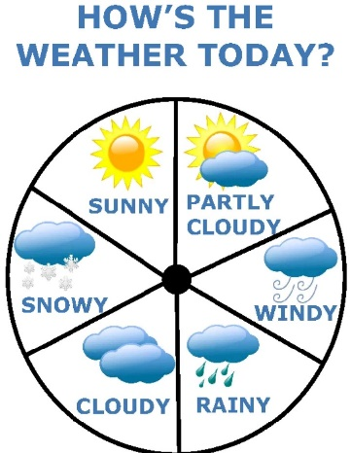  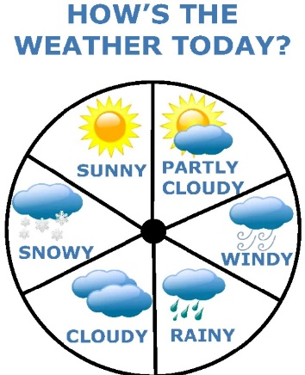  Ask learners to use letter cards and match with the pictures. |  |  |  |  | Pictures and Charts, the big book, pencils and crayons
GROUP ACTIVITY 1  (OUTDOOR) | Let learners tell which set of objects has more or less.  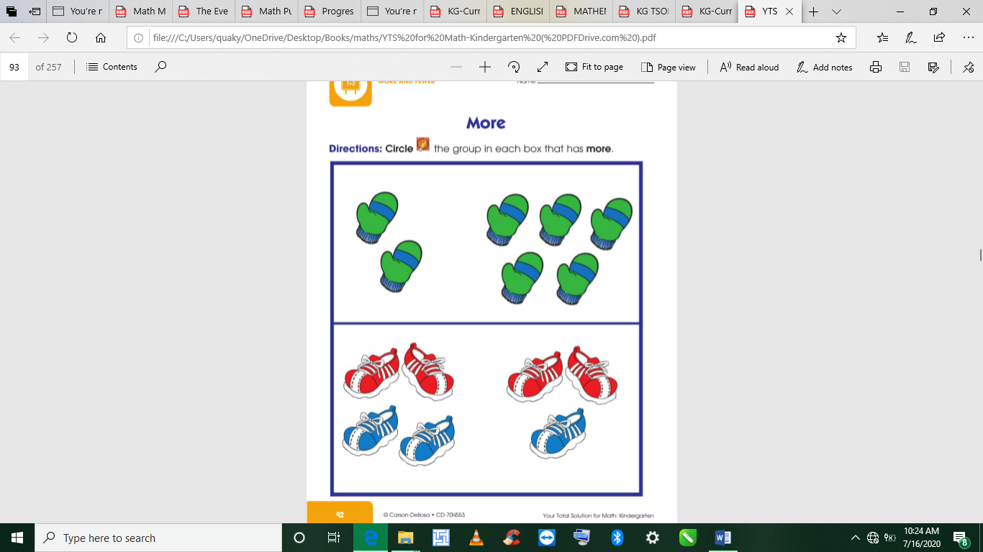  Extend this activity to include objects in and outside the classroom.  Teach, sing songs and recite rhymes in relation to the lesson.  Learners to sing the songs, recite rhymes and dance with actions.  Make a choice to use any of the learning centers created.
PHONICS | Engage learners to sing songs and recite some familiar rhymes that relates to the target sound.  Guide learners to pronounce and write the target sound in the sand tray or exercise books.  Have learners say three or four words that contain the target sound.  Using flash cards, learners read words that contain the target sound.  1. What sound have we learnt today?  2. Which other letter sound do you know?  3. Mention any object in the classroom or home that begins with the target letter sound. |  |  |  |  | Word cards, letter cards.
GROUP ACTIVITY 2  (INDOOR) | Using pictures, guide learners to identify and name the initial letter sounds of the various weather conditions.  Ask learners to use letter cards and match with the pictures.  Guide learners to write the letter sounds under each picture of the weather conditions. You can let them post the letter under the picture too.  Have learners to draw and color some weather conditions in their books. |  |  |  |  | Pictures and Charts, the big book, pencils and crayons
LEARNING CENTER | Engage learners to play freely at the learning centers.  Observe, join in and ask learners questions frequently to guide their play and to support their understanding in what they are learning. |  |  |  |  | Learning center
STORY SHARING | Tell learners a story.  Pause regularly and ask questions to make sure learners are following.  Engage learners to act parts of the story.  1. Was the story interesting?  2. What part of the story did you like?  3. what have you learnt from the story? |  |  |  |  | Word cards, letter cards.
PHASE 3: REFLECTION | Review lesson with Learners by singing songs in relation to it

Date: |  | Day: THURSDAY |  |  | Strand: All Around Us
 |  |  |  |  | Sub Strand: CHANGING WEATHER CONDITIONS
Class: KG 1 |  |  | Class Size:
Content Standard:  K1.6.9.1 Demonstrate understanding of changing weather conditions and seasons. |  |  |  | INDICATORS: K1.6.9.1.4 Use the vocabulary learnt to talk about the weather.
Performance Indicator:  Use the vocabulary learnt to talk about the weather. |  |  |  |  | Core Competencies:  Communication and collaboration, Critical thinking, Personal Development and Leadership
Keywords: decode, blend, initial.
Reference : KG Curriculum P.g. 76-79
Phase/Duration | Learners Activities |  |  |  |  | Resources
PHASE 1: STARTER | Engage learners to sing songs and recite familiar rhymes  MISS POLLY HAD A DOLLY  Miss Polly had a dolly who is sick, sick, sick  So she phoned for the doctor to come quick, quick, quick.  The doctor came with his bag and his hat,  And knocked at the door with a rat-a-tat-tat.  He looked at the dolly and shook his head.  And said “Miss Polly put her straight to bed”  He wrote a paper for a pill, pill, pill.  I’ll be back in the morning with the bill, bill, bill.
PHASE 2: NEW LEARNING  CIRCLE TIME | In a community circle time, have learners talk about the different uses of the sources of light on a conversations poster.  Have learners discuss the uses of light in their everyday life using the new vocabulary learnt.
GROUP ACTIVITY 1  (OUTDOOR) | Take leaners out of the class to the field for a stretch up.  Learners sing rhymes and dance with actions  Engage leaners to use any of the play toys available.  Make a choice to use any of the learning centers created
PHONICS | Engage learners to sing songs and recite some familiar rhymes that relates to the target sound.  Guide learners to pronounce and write the target sound in the sand tray or exercise books.  Have learners say three or four words that contain the target sound.  Using flash cards, learners read words that contain the target sound.  1. What sound have we learnt today?  2. Which other letter sound do you know?  3. Mention any object in the classroom or home that begins with the target letter sound. |  |  |  |  | Word cards, letter cards.
GROUP ACTIVITY 2  (INDOOR) | Discuss the different weather conditions on a conversational poster with learners.  Show keywords on cards and guide learners to read e.g. rainy, windy, sunny, cloudy, rain, wind, etc.  Ask them to form sentences orally with the vocabulary acquired.  Put learners into groups. Give each group picture- word cards of names of the weather – rainy, windy, sunny, cloudy, rain, wind, sun, cloud.  In turns learners pick and read out a card and say one thing about the word.  Make a chart from the words they read. Have learners draw and color any of the weather conditions and talk about it. |  |  |  |  | Pictures and Charts, the big book, pencils and crayons
LEARNING CENTER | Engage learners to play freely at the learning centers.  Observe, join in and ask learners questions frequently to guide their play and to support their understanding in what they are learning. |  |  |  |  | Learning center
STORY SHARING | Tell learners a story.  Pause regularly and ask questions to make sure learners are following.  Engage learners to act parts of the story.  1. Was the story interesting?  2. What part of the story did you like?  3. what have you learnt from the story? |  |  |  |  | Word cards, letter cards.
PHASE 3: REFLECTION | Learners share what they have learnt with their peers and class.  Give learners homework to do at home.

Date: |  | Day: FRIDAY |  |  | Strand: All Around Us
 |  |  |  |  | Sub Strand: CHANGING WEATHER CONDITIONS
Class: KG 1 |  |  | Class Size:
Content Standard:  K1.6.9.1 Demonstrate understanding of changing weather conditions and seasons |  |  |  | Indicator: K1.6.9.1.5 Identify, observe and talk about art in the immediate
Performance Indicator:  Identify, observe and talk about art in the immediate |  |  |  |  | Core Competencies:  Communication and collaboration, Critical thinking, Personal Development and Leadership
Keywords: Position sentence, blowing breath, blow.
Reference : KG Curriculum P.g. 76-79
Phase/Duration | Learners Activities |  |  |  |  | Resources
PHASE 1: STARTER | Engage learners to sing songs and recite familiar rhymes  COBBLER, COBBLER, MEND MY SHOE  Cobbler, cobbler, mend my shoe,  Get it done by half past two.  Half past two is much too late.  Get it down by half past eight.  Stitch it up and stitch it down.  And I’ll give you half a crown.
PHASE 2: NEW LEARNING  CIRCLE TIME | Using a conversational poster of the sources of light depicting day and night, guide learners to identify the natural and artificial sources.  Have learners describe the beauty of the day and night scenes.
GROUP ACTIVITY 1  (OUTDOOR) | Teacher sings songs and recite rhymes in relation to the lesson with learners  Take learners out to the field.  Guide them to swing the sea-saw, sit on the mary-go-round etc.  Sing rhymes and songs with learners as they play.
PHONICS | Engage learners to sing songs and recite some familiar rhymes that relates to the target sound.  Guide learners to pronounce and write the target sound in the sand tray or exercise books.  Have learners say three or four words that contain the target sound.  Using flash cards, learners read words that contain the target sound.  1. What sound have we learnt today?  2. Which other letter sound do you know?  3. Mention any object in the classroom or home that begins with the target letter sound. |  |  |  |  | Word cards, letter cards.
GROUP ACTIVITY 2  (INDOOR) | Using the pictures of the weather, let learners talk about the beauty of each of them.  Assist them use the weather vocabulary to make simple sentences (You can make some of these sentences on strips).  Have Learners make their own pictures and talk about them.  Give out some numeral cards, let learners compare the numbers by using the comparative language “more than”, “less than”, “same as.  Let learners compare the number of objects in the class room. E.g. the pencils are more than the erasers.  Make a choice to use any of the learning centers created |  |  |  |  | Pictures and Charts, the big book, pencils and crayons
LEARNING CENTER | Engage learners to play freely at the learning centers.  Observe, join in and ask learners questions frequently to guide their play and to support their understanding in what they are learning. |  |  |  |  | Learning center
STORY SHARING | Tell learners a story.  Pause regularly and ask questions to make sure learners are following.  Engage learners to act parts of the story.  1. Was the story interesting?  2. What part of the story did you like?  3. what have you learnt from the story? |  |  |  |  | Word cards, letter cards.
PHASE 3: REFLECTION | Teacher sings songs and recite rhymes in relation to the lesson with learners  Take learners out to the field.  Guide them to swing the sea-saw, sit on the mary-go-round etc.  Sing rhymes and songs with learners as they play  Give learners homework to do at home.

